Make your Security Camera a Telephoto Camera - The Wrong Way and the Right Way

PART I - Initial Presentation - August 2018

PART II - Second Presentation Octobor 2018

Additional information on use of ISPY

PART I:

Outline

Traffic Tracking

Setting up a traffic monitor in ISPY using SRICAM SP019 Camera.

1. Standard view from 1.3MB camera
2. View from ISPY “Edit/Motion Detection”

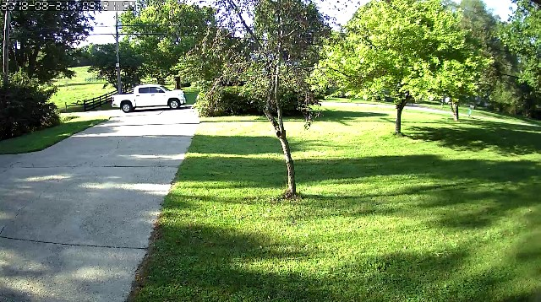

ISPY “Edit/Motion Detection” Setup

Supress Noise

Trigger Range - Minimum, Maximum (overload)

2 selected areas <next page>

day/night comparison

ISPY Edit Camera/Motion Detection

Suppress Noise

Trigger Range

Gain

Process Every (default 200)

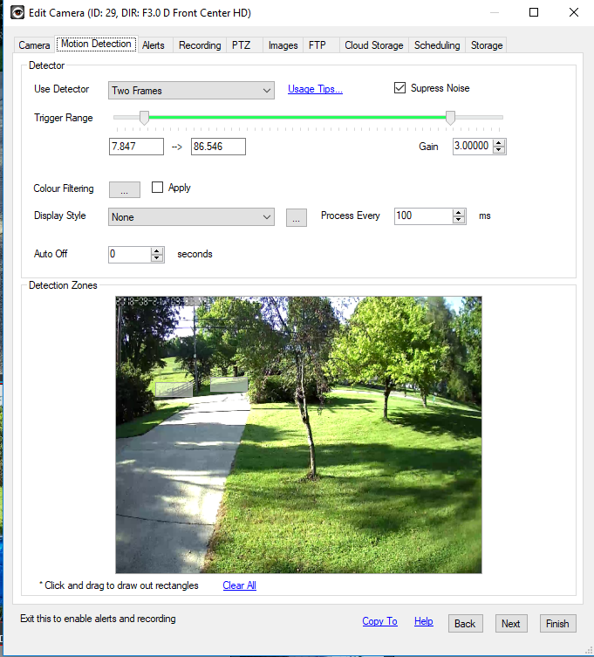

Day/Night Comparison

In the night photo (right): Note the headlights lighting up the area to the right of the light pole.

If you use this area to trigger your photo you will trigger early (as with this photo).

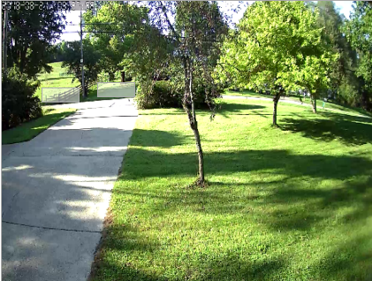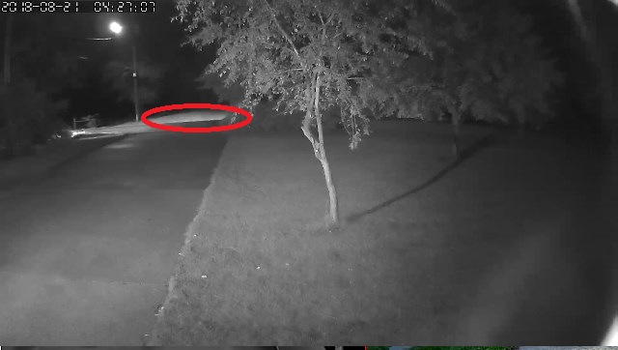

II. The Telephoto Camera

NO TELEPHOTO - This is a photo from an SP012 camera without telephoto

With this particular camera (720) the resolution of the vehicle is not great. We could probably improve the focus a tad, but just not that great.

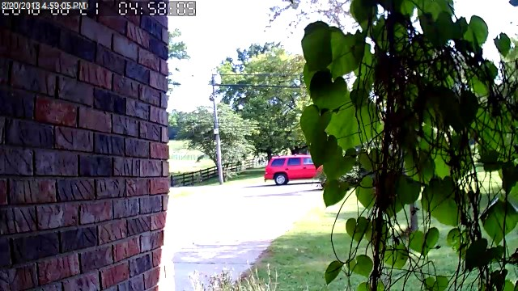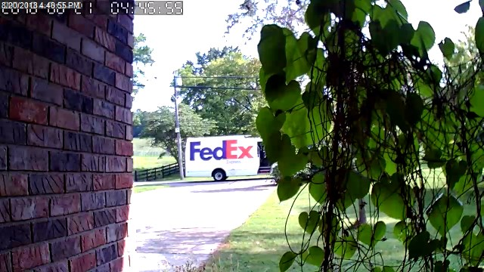

Telephoto Picture: Compare the regular picture (left) to the telephoto picture (right).

Note the improved resolution of the trees

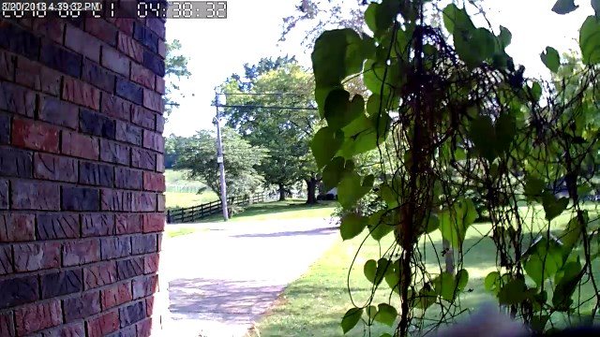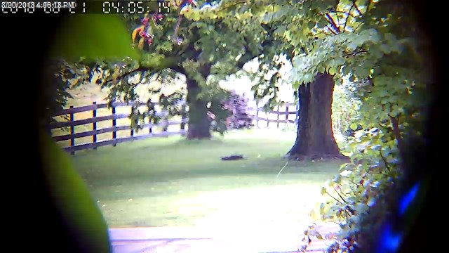

This is before and after a manual focus of the Telephoto lens. The camera was moved to the left and down to catch the road itself.

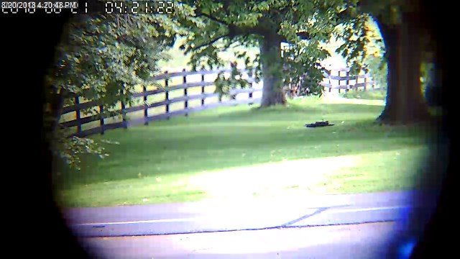

The bush on the left would definately catch some lights from vehicle headlights, so we won’t include it in the left trigger area. This would cause early trigger.



Vehicle pictures using Telephoto Lens Kit

Uhhh Ohhh!!

We have a several problems here!

1. Frame is too small for entire vehicle.
2. Picture is fuzzy (movement too fast for camera?)
3. Picture is slanted (movement to fast for camera?)

**Summary (for this case):**

**12x is too much for the SP012**

**Ordered 16mm Lens**

| **16mm** | **20°** | **16mm(L)*12mm(D)** |
| --- | --- | --- |

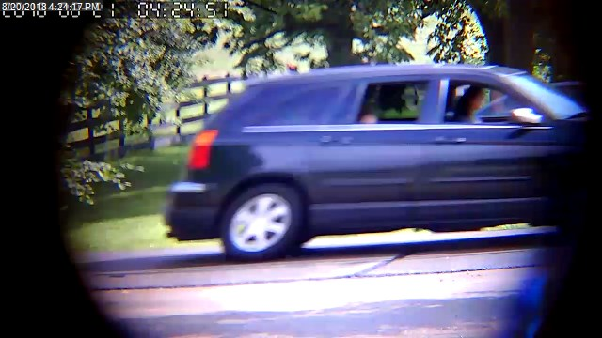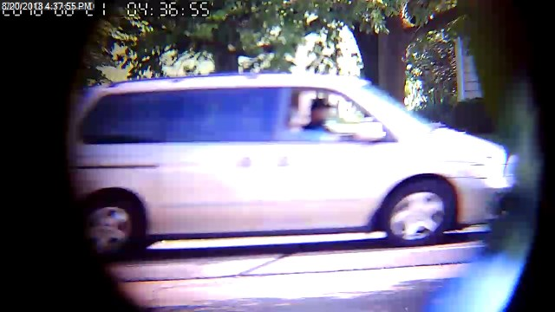

Left: SRICAM SP012 720P <$25

Right: Customized - SRICAM SP012 720P <$2500 (special, last one!)

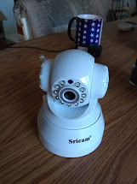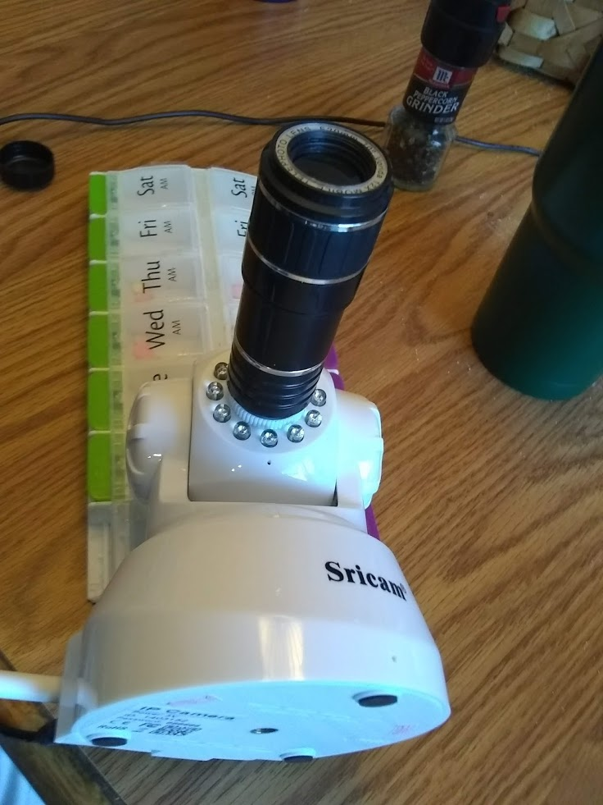

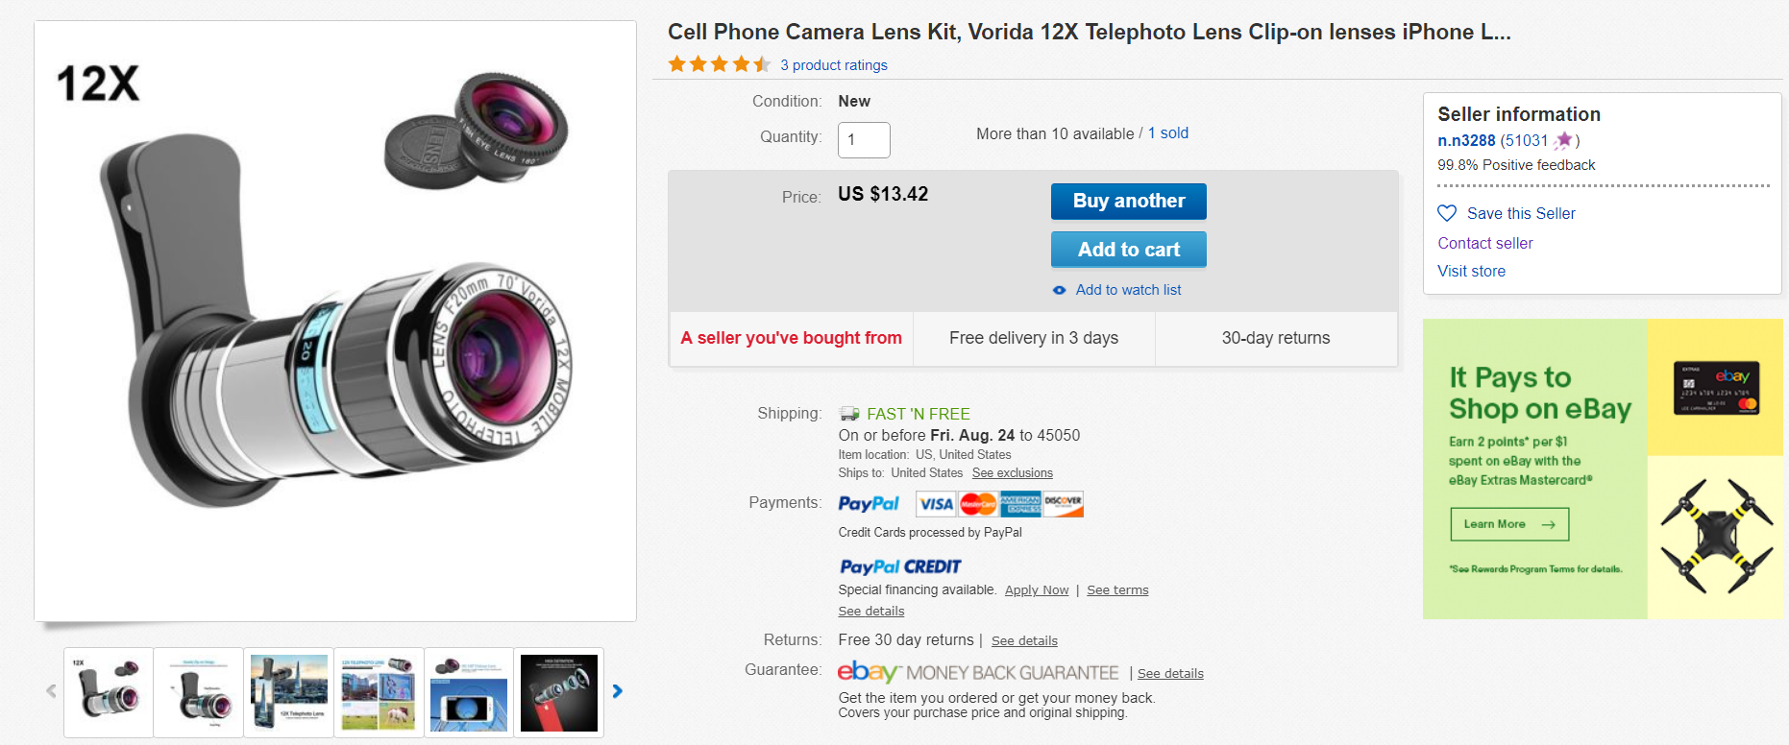

**The “Right Way”**

**EBAY M12x0.5 F2.0 Fixed IR Board Camera Lens 1.56/1.8/2.1/2.5/2.8/3.6/6/8/12/16/25MM $2.99**

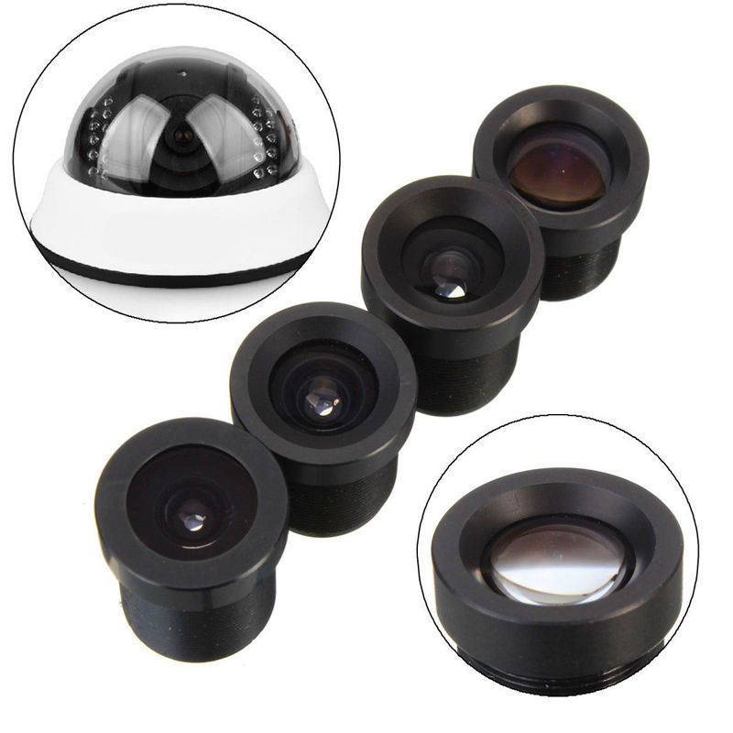

| **Focal Length** | **Angle of View** | **Size** |
| --- | --- | --- |
| **1.8mm** | **170°** | **11mm(L)*12mm(D)** |
| **2.1mm** | **150°** | **13mm(L)*12mm(D)** |
| **2.5mm** | **130°** | **17mm(L)*12mm(D)** |
| **2.8mm** | **115°** | **17mm(L)*12mm(D)** |
| **3.6mm** | **92°** | **15mm(L)*12mm(D)** |
| **6mm** | **53°** | **15mm(L)*12mm(D)** |
| **8mm** | **40°** | **14mm(L)*12mm(D)** |
| **12mm** | **25°** | **16mm(L)*12mm(D)** |
| **16mm** | **20°** | **16mm(L)*12mm(D)** |

THE RIGHT WAY 9/11/2018

Added 16MM lens to SP012 Camera with results similar to those presented at the club meeting. (Telephoto?)

16MM is a bit too much magnification

large vehicles are out of frame.

pictures are blurred and skewed in low light - cars to fast for camera

The lens assy. focused about 1/4 inch out from original position

Magnification is great! Viewing birds in trees is much improved.

With increased magnification the LED IR lamps DO NOT HELP at

increased distances.

The 16mm lens will help viewing the field behind the barn (during daylight).

Bird feeder activity is viewable but not snapshot quality. (30 ft).

PTZ is OK for distant objects. Can't easily set position for close up items.

If you want to get a license plate (1/3 plate per frame) you would need

manually position the camera for that granularity. (set position(s) as preset).

[New Improved Photos](https://photos.app.goo.gl/7bERcUSdLr7pYrcr7)

PART II:

We tried a 12MM lens and found the magnification was still too great.

We tried a 10MM lens and the magnifiction was OK.

The desired area was covered.

* Had enough coverage to include a trigger are for both directions (insure vehicle was in frame) 90 percent of time.
* Was large enough for bus or truck

ISPY (PC (windoze) capture software adjustments.

* Frame rate was adjusted to 5 FPS.
* Alarm check rate was adjusted to 100 ms instead of the default (200)
* The alarm check rate for all other cameras was set to 300 (fine for 2 FPS) due to excessive CPU use.
* Using narrow (horizontal) trigger zones and increasing gain seems to improve trigger response and reduce falseing.

Results:

* Daylight Pictures are good and 90 percent are 100% in frame.
* Evening and early morning (lower light) a somewhat blurred.
* Night pictures are blurry.
* Keep in mind this is a $22 PTZ 720P camera
* I am considering a lens with a larger aperture (reduce blurring).